**UNLOCKING INSIGHTS INTO GLOBAL AIR TRANSPORTATION NETWORK ………**

**PROJECT REPORT**

**1 .INTRODUCTION :**

* 1. **GROUP INTRODUCTION :**

**TEAM LEADER :** P.THARANI

**TEAM MEMBERS :** P.DHARANISRI, S.MONIKA, M.DEVI, K.DIVYA

**1.2 OVERVIEW :**

First I created an EMPATHY MAP. A map has four quadrants –Says ,Thinks, Does and Feels. How to airplanes get the signal .What are all the difficulties passengers facing .This are the things shown in four quadrants. Next I created BRAINSTROME. Our team take a problem statement and we discuss about problems the passengers faced while travelling in airplanes .Our problem statement is “WHEN THERE IS SUDDEN CHANGE IN CLIMATE DURING MIDFLIGHT THE PILOT STRUGGLES VERY HARD TO TAKE CONTROL OF THE PLANE SOMETIMES ACCIDENTS TOO OCCUR .THIS MAKES THE PEOPLE FEEL UNSAFE AND AVOID THE AIR TRANSPORTATIONS” .Then I created my data analysis –Dashboard and Story .Next step I published my Dashboard and Story in tableau public .

**1.3 PURPOSE :**

Data analytics help a business optimize its performance, perform more efficiently, maximize profit, or make more strategically-guided decisions. The techniques and processes of data analytics have been automated into mechanical processes and algorithms that work over raw data for human consumption.

**2. PROBLEM DEFINITION &DESIGN THINKING :**

**2.1 EMPATHY MAP :**

An empathy map is a collaborative tool teams can use to gain a deeper insight into their customers. Much like a user persona, an empathy map can represent a group of users, such as a customer segment. The empathy map was originally created by Dave Gray and has gained much popularity within the agile community.

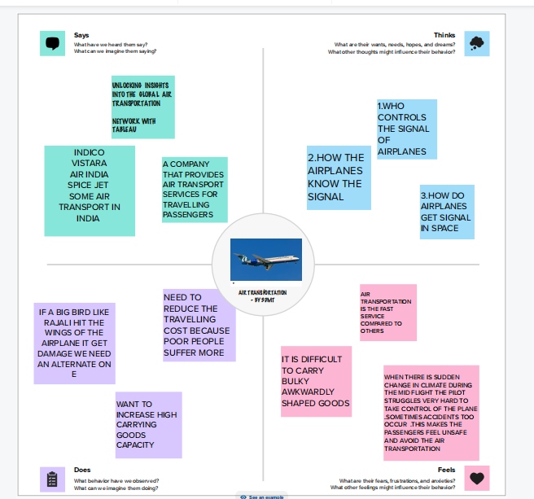

**2.2 IDEATION &BRAINSTROMING MAP :**

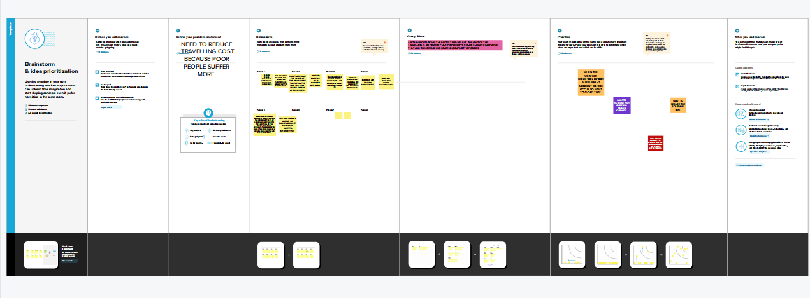

**RESULT:**

**DASHBOARD :**

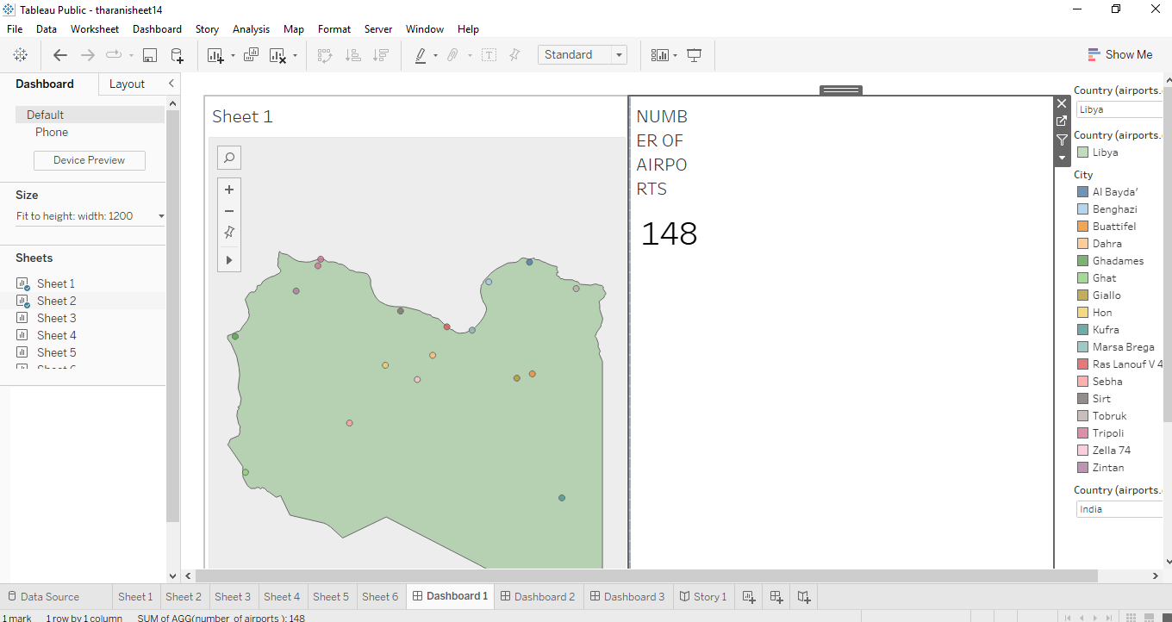

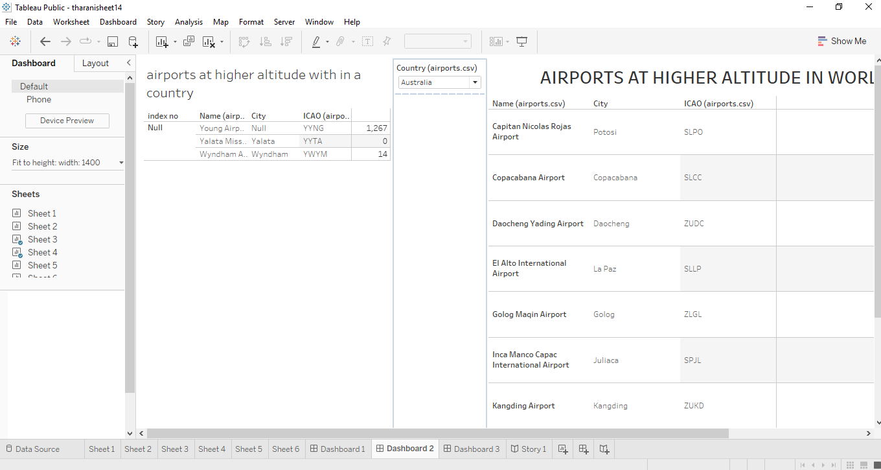

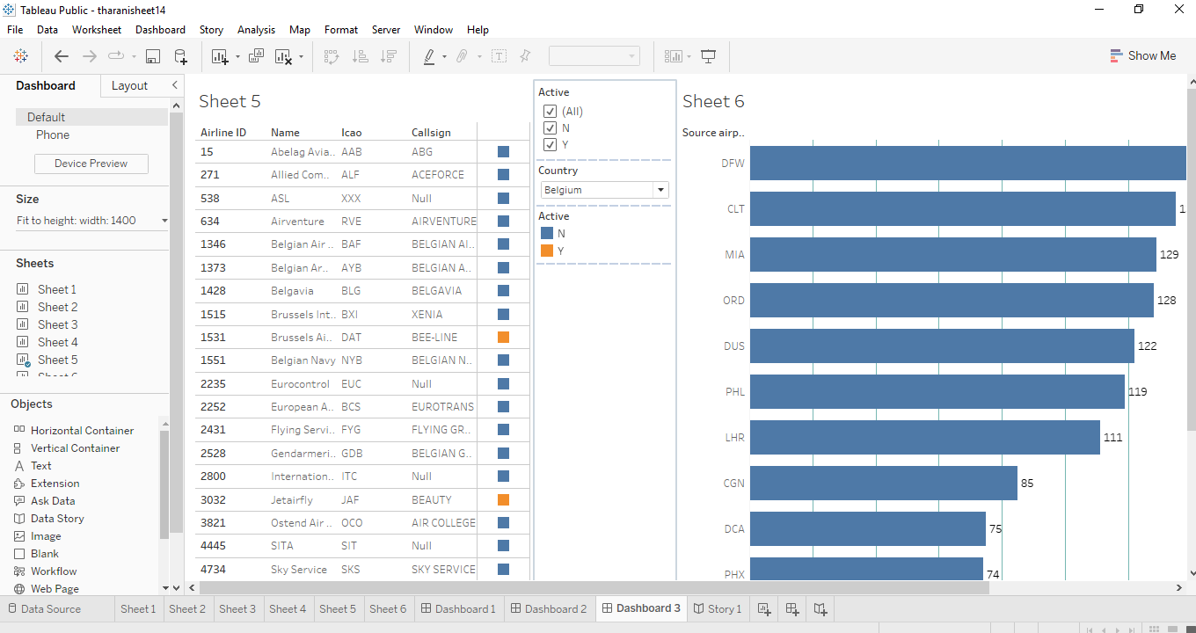

**STORY:**

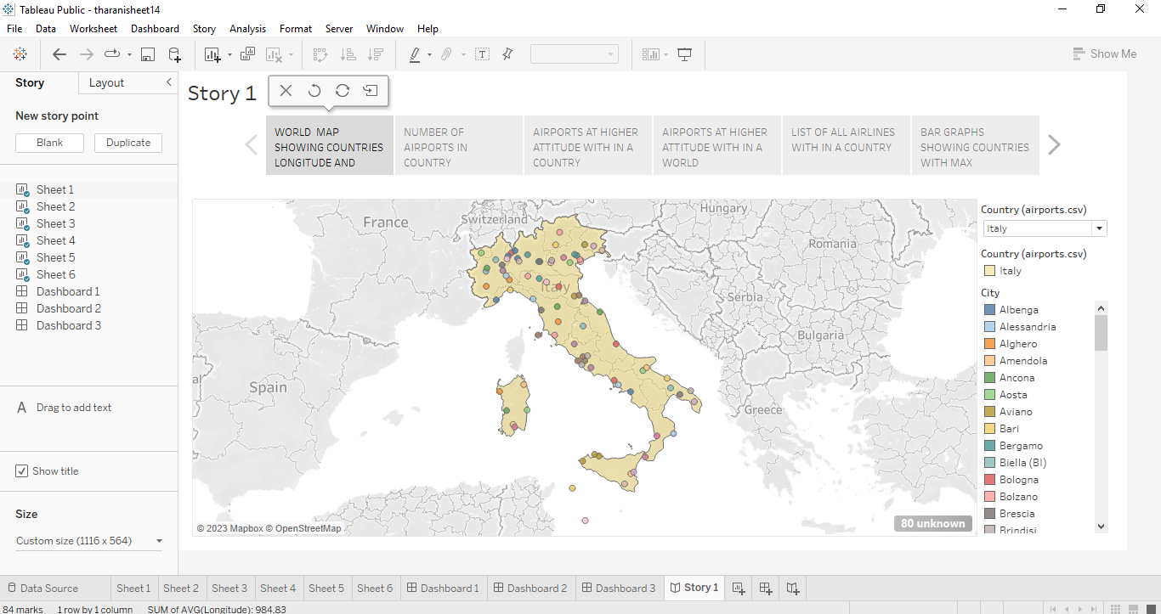

Map based on average of longitude and average of latitude .color shows details about country and city. Details are shown in various dimensions .The view is filtered on country which keeps Italy.

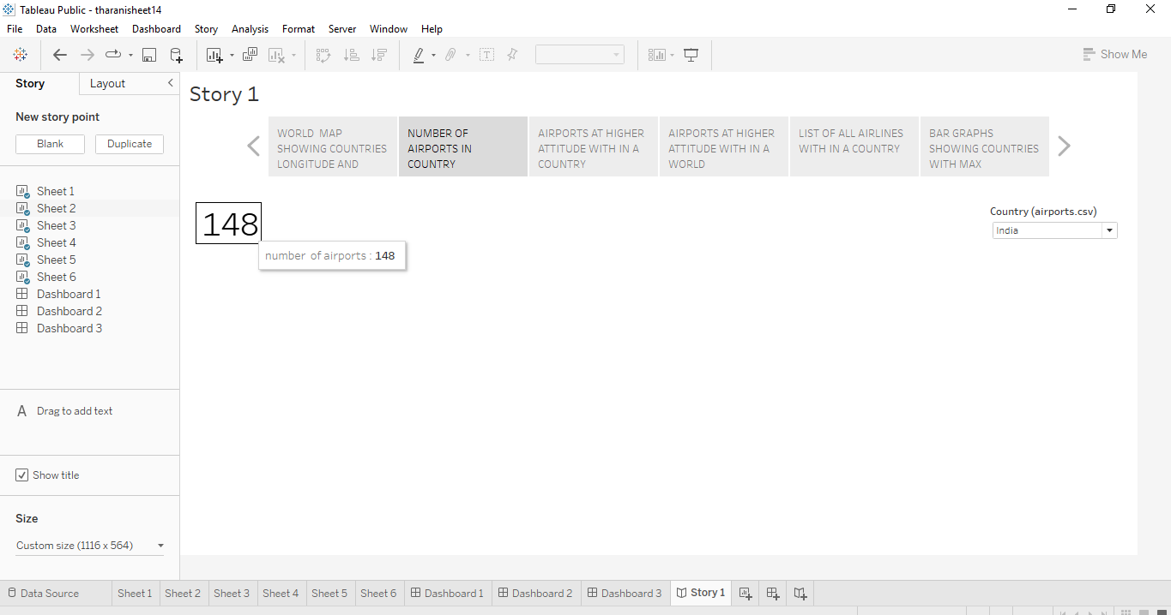

Number of airports .The data is filtered on country which keeps INDIA .

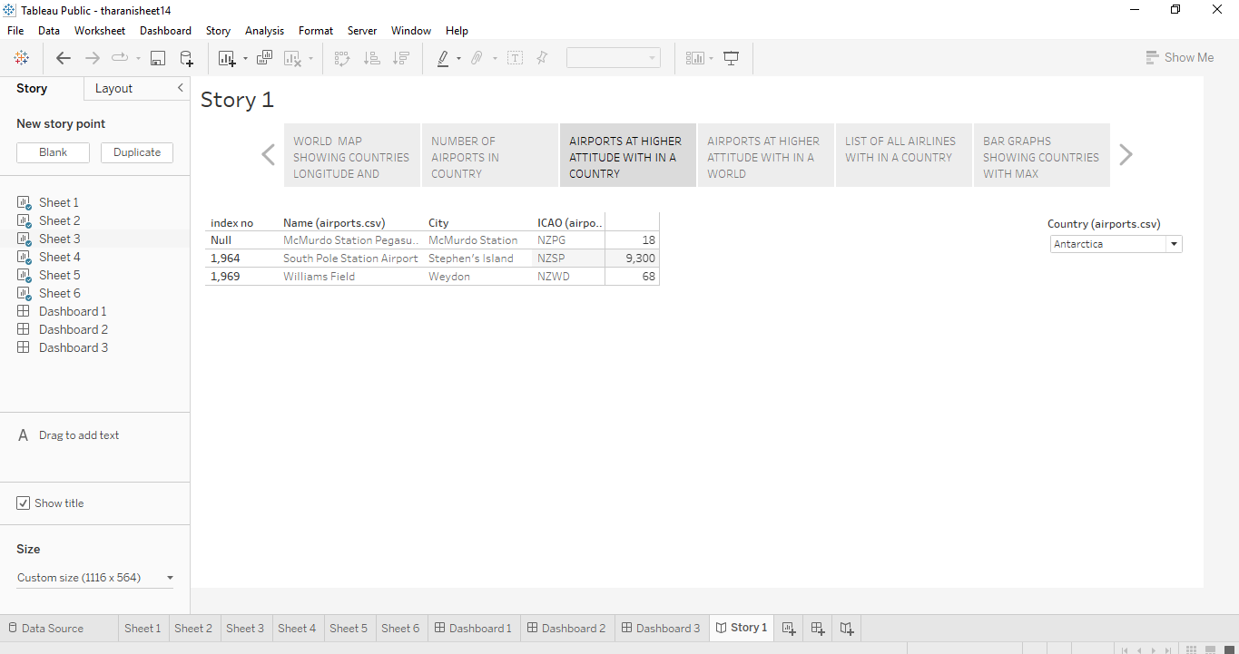

Sum of altitude is broken down by index no .Name of airports ,city,ICOA. The data is filtered on country are top n.The country filtered keeps Antarctica .The top n filter keeps True .

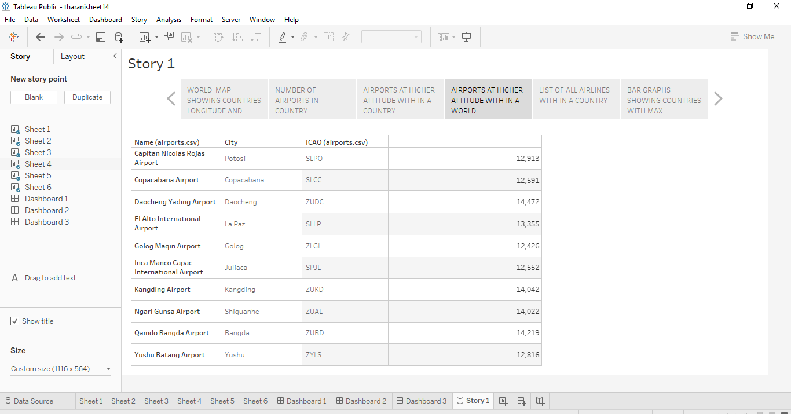

Sum of altitude broken down by Name ,city,ICOA. The view is filtered on ICOA ,which keeps 10 of 7,698 members .

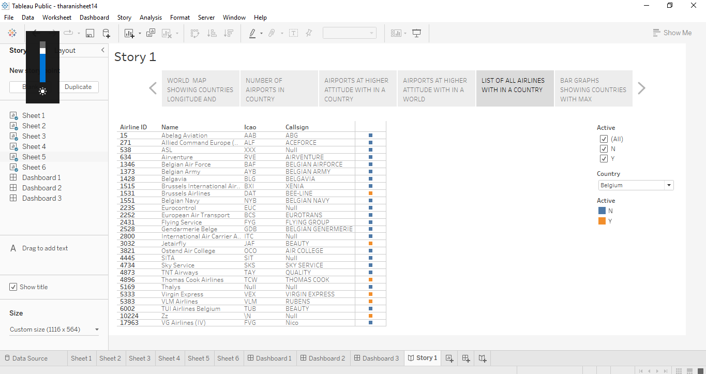

Active broken down by AIRPLANE ID ,Name ,ICOA and Call sign .The data is filtered on country ,which keeps Belgium .The view is filtered on active ,which keeps n,N and Y.

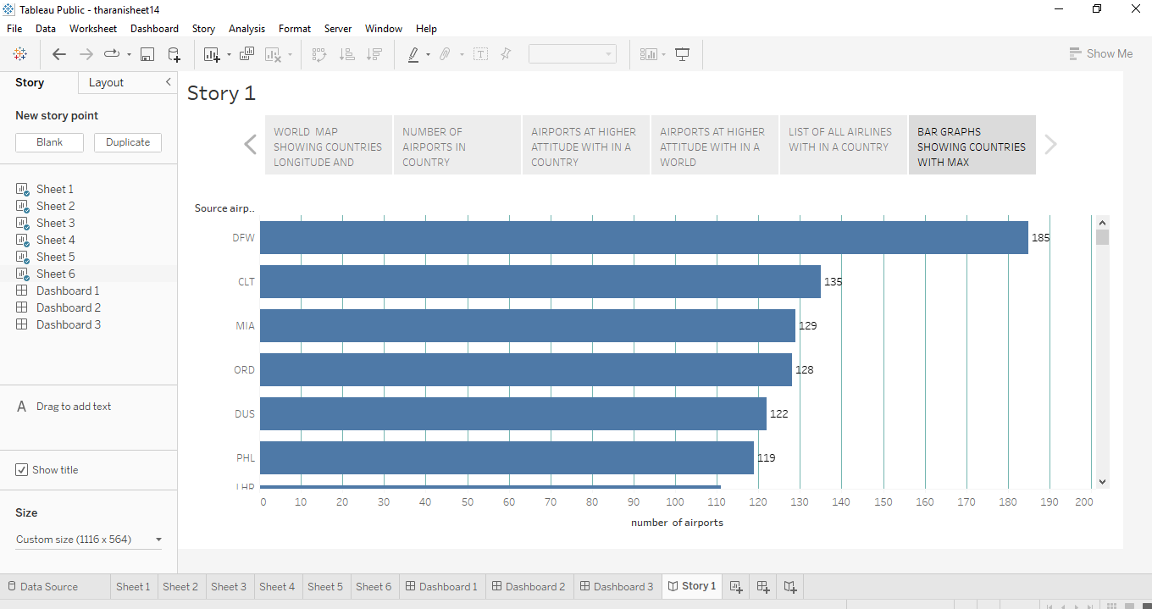

Number of airports for each source airports.

**4.ADVANTAGES :**

High Speed. Air is the type of freight capable of traveling long distances in short periods of time. ...

Fast Service. ...

Send almost everywhere your freight. ...

High Standard of Security. ...

Natural Route. ...

There is less need for heavy packaging. …

**DISADVANTAGES :**

High Cost. This is significantly more costly for its services than land, rail, and water transportation. ...

* Risky. ...
* Limited capacity. ...
* Uncertain and Unreliable. ...
* Accident-prone. ...
* Requires Skill. ...
* Large Investment. ...
* Unfit for cheap and bulky goods.

1. **APPLICATIONS :**

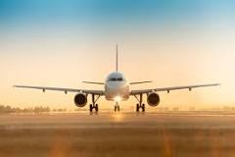

Air transport is currently used in almost all industrial sectors and distribution chains. Most companies use air transport to market goods and products internationally or to deliver samples and documents related to foreign trade operations.

1. **CONCLUSION:**

In this we see the empathy map that shows who they feel while travelling in the airplanes .And next while be a brainstorm that says about the problems what the passengers feel while travelling.And next will be a data analysis that shows countries latitude and longitude .

1. **FUTURE SCOPE :**

Want to increase the goods carrying capacity and needs to reduce the cost of travelling because poor peoples suffer more if we change this the future scope is very useful for all rich and poor peoples .